DEPARTMENT OF ARTIFICIAL INTELLIGENCE AND DATA SCIENCE

Laboratory Record Manual

B.Tech

Semester III

22AI304
PRINCIPLES OF PROGRAMMING LABORATORY

Academic Year 2025-2026

DEPARTMENT OF ARTIFICIAL INTELLIGENCE AND DATA SCIENCE
22AI304
PRINCIPLES OF PROGRAMMING LABORATORY

List of Experiments

Experiment No. | Experiment Name | Page No.
1 | Online shopping cart: Develop an application to implement an online shopping cart and generate bills for the purchased products. | 3
2 | Pocket Bazaar: Develop an application to manage an inventory of products for grocery stores. | 9
3 | Vacation Destination Decision Maker: Create an application program that helps a user decide on their next vacation destination based on their preferences. | 14
4 | Temperature monitor: Develop an application for a temperature monitoring system and provide an alert message. | 19
5 | Develop an access control system that simulates the granting access to authorized personnel based on their credentials, such as ID cards and PIN codes. | 22
6 | Math Quiz Generator: Design a math quiz generator that generates questions of various difficulty levels and arithmetic operations. | 27
7 | Build a maze solver application that finds a path from the entrance to the exit of a maze. | 33

EX NO:01 | ONLINE SHOPPING CART: DEVELOP AN APPLICATION TO IMPLEMENT AN ONLINE SHOPPING CART AND GENERATE BILLS FOR THE PURCHASED PRODUCTS

AIM:
The aim of this experiment is to develop an application using Python to implement an online shopping cart and generate bills for the purchased products.

PROCEDURE:
Step 1: Initialize an empty shopping cart (usually a list or data structure) to store the selected products and initialize variables to keep track of the total bill and any discounts or promotions.
Step 2: Display a list of available products to the user, typically fetched from a database or hard-coded in the application and allow the user to add products to the shopping cart by specifying the product's name, quantity, and price.
Step 3: Update the shopping cart by adding or removing products as per the user's selection and Calculate the subtotal for each product (quantity * price) and update the total bill.
Step 4: Implement any discounts or promotions that may apply, such as percentage discounts, buy-one-get-one deals, or special offers and update the total bill with the applied discounts.
Step 5: Calculate any applicable taxes (e.g., sales tax) and add them to the total bill.
Step 6: Display an itemized bill to the user, listing the selected products, quantities, prices, and subtotals and display the total bill, including discounts, taxes, and the final amount to be paid by the customer.
Step 7: If your application supports online payments, integrate a payment gateway to allow users to make the payment and update the transaction history and order records in your database.
Step 8: Provide options for the user to continue shopping, clear the cart, or exit the application.

PROGRAM:
# Shopping cart with bill generation
# User Details
name = "Am1"
address = "VSKP"
phone_number = "9999988888"
# Item list with price
items = [
{"name": "Orange", "price": 1.00},
{"name": "Banana", "price": 2.00},
{"name": "Tomato", "price": 3.00},
{"name": "Grape", "price": 2.50},
{"name": "Pear", "price": 10.00},
{"name": "Lemon", "price": 0.50}
]
# Cart dictionary to store item_name: quantity
cart = {}
def display_menu():
print(f"\nName: {name}")
print(f"Address: {address}")
print(f"Phone Number: {phone_number}")
print("\n----------- Items Menu -----------")
print("Sno Item Name Price each(in $)")
print("------------------------------------")
for i, item in enumerate(items, start=1):
print(f"{i} {item['name']:<12} {item['price']:.2f}")
print("7 Exit")
print("------------------------------------")
def update_cart(choice, quantity):
item = items[choice - 1]
item_name = item['name']
if item_name in cart:
cart[item_name] += quantity
else:
cart[item_name] = quantity
print("Cart Updated...\n")
def generate_bill():
print("\n----------- FINAL BILL -----------")
print(f"Customer Name: {name}")
print(f"Address : {address}")
print(f"Phone Number : {phone_number}")
print("----------------------------------")
print(f"{'Item':<12} {'Qty':<5} {'Price($)':<10} {'Total($)':<10}")
print("----------------------------------")
grand_total = 0
for item in cart:
quantity = cart[item]
price = next(i['price'] for i in items if i['name'] == item)
total = quantity * price
grand_total += total
print(f"{item:<12} {quantity:<5} {price:<10.2f} {total:<10.2f}")
print("----------------------------------")
print(f"{'Grand Total':<29} {grand_total:.2f}")
print("----------------------------------")
print("Thank you for shopping with us!")
# Main loop
while True:
display_menu()
try:
choice = int(input("Your Choice: "))
if choice == 7:
break
elif 1 <= choice <= 6:
quantity = int(input("Input Quantity: "))
update_cart(choice, quantity)
else:
print("Invalid choice. Try again.\n")
except ValueError:
print("Invalid input. Enter numbers only.\n")

# Generate the bill
if cart:
generate_bill()
else:
print ("No items purchased.")
SAMPLE OUTPUT:

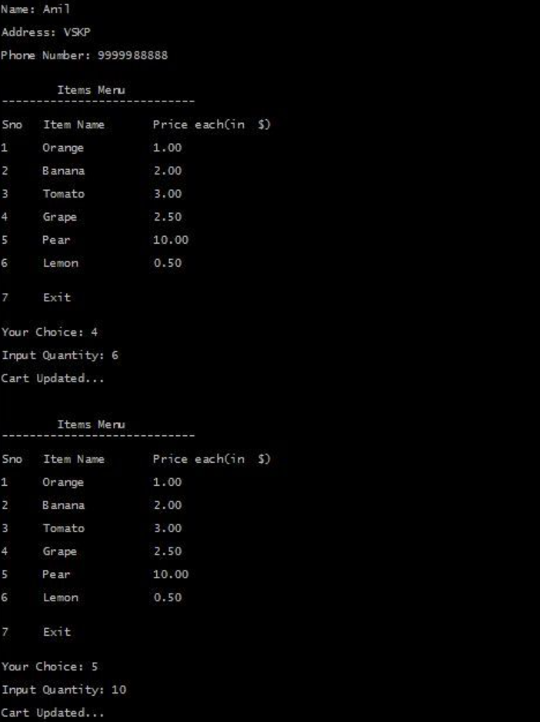

VIVA OR STIMULATING QUESTIONS:
- Why did you choose a specific data structure (e.g., list) for the shopping cart? Are there alternative data structures that could be used?
- How would you optimize your data structure if the size of the product catalog becomes very large?
- How would you refactor your code to make it more modular and reusable?
- How did you implement error handling in your Python code, especially when dealing with user inputs?
- How did you format strings for displaying the itemized bill? Are there Python string formatting techniques you found particularly useful?
- How might you use a dictionary to store information about discounts or promotions?
- How might you design a class to represent a "Product" in your application?
- Can you demonstrate the use of an f-string or other string formatting methods in your code?

RESULT:
Thus, the application to implement an online shopping cart and generate bills for the purchased products is developed using Python programming.

EX NO:02 | POCKET BAZAAR: DEVELOP AN APPLICATION TO MANAGE AN INVENTORY OF PRODUCTS FOR GROCERY STORES

AIM:
The aim of this experiment is to develop an application using Python to manage an inventory of products for grocery store to purchase products.

PROCEDURE:
Step 1: Create a Python class to represent a product. This class should have attributes like name, price, quantity, and category. Create another class to manage the inventory. This class should have methods for adding, updating, and displaying products.
Step 2: Create a database to store product information. SQLite, MySQL, or PostgreSQL are popular choices.
Step 3: Create a user interface for interacting with the application. Use the built-in Python input() function for command-line interfaces, or choose a GUI library like Tkinter or a web framework like Flask or Django for a more advanced interface.
Step 4: Implement the core functionality such as Add new products to the inventory, Update existing product details, Display the list of products and Implement error handling to deal with invalid inputs or data retrieval issues.
Step 5: Display the inventory shopping cart based on the choices selected by the user
Step 6: Continue to interact with the program by selecting options 1, 2, or 3 or exit the program by selecting option 4.

PROGRAM:
class Product:
def __init__(self, name, price, quantity, category):
self.name = name
self.price = price
self.quantity = quantity
self.category = category
class Inventory:
def __init__(self):
self.products = {}
def add_product(self, product):
if product.name not in self.products:
self.products[product.name] = product
print("Product added to the inventory.")
else:
print("Product already exists in the inventory.")
def update_product(self, product):
if product.name in self.products:
self.products[product.name] = product
print(f"{product.name} updated successfully.")
else:
print("Product not found in the inventory.")

def display_inventory(self):
if not self.products:
print("\nInventory is empty.")
else:
print("\nCurrent Inventory:")
print(f"{'Name':<15} {'Price':<10} {'Quantity':<10} {'Category':<15}")
print("-" * 50)
for product in self.products.values():
print(f"{product.name:<15} {product.price:<10.2f} {product.quantity:<10} {product.category:<15}")
def main():
inventory = Inventory()
while True:
print("\nPocket Bazaar - Inventory Management")
print("1. Add a product to the inventory")
print("2. Update product details")
print("3. Display inventory")
print("4. Exit")
choice = input("Enter your choice: ")
if choice == '1':
name = input("Enter product name: ")
try:
price = float(input("Enter product price: "))
quantity = int(input("Enter product quantity: "))
category = input("Enter product category: ")
product = Product(name, price, quantity, category)
inventory.add_product(product)
except ValueError:
print("Invalid input. Price should be a number and quantity should be an integer.")
elif choice == '2':
name = input("Enter product name to update: ")
if name in inventory.products:
try:
price = float(input("Enter updated product price: "))
quantity = int(input("Enter updated product quantity: "))
category = input("Enter updated product category: ")
updated_product = Product(name, price, quantity, category)
inventory.update_product(updated_product)
except ValueError:
print("Invalid input. Price should be a number and quantity should be an integer.")
else:
print(f"{name} not found in the inventory.")
elif choice == '3':
inventory.display_inventory()
elif choice == '4':
print("Exiting Pocket Bazaar. Thank you.")
break

else:
print("Invalid choice. Please try again.")
if __name__ == "__main__":
main()
SAMPLE OUTPUT:

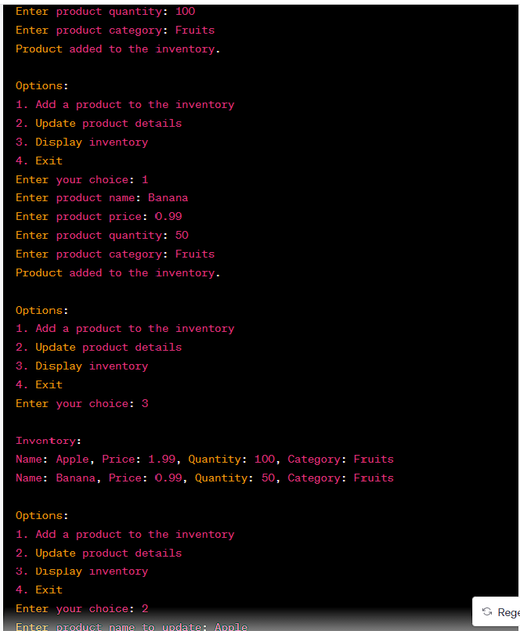

VIVA OR STIMULATING QUESTIONS:
- Why did you choose to represent a product using a class in Python? Can you explain the attributes you included in the product class?
- How might you extend the product class to include additional features or behaviors?
- How did you handle database connections, queries, and transactions in your Python code?
- Describe the user interface options you considered for your application. Why did you choose the input() function or a specific GUI/web framework?
- How would you enhance the user interface to make it more user-friendly and intuitive?
- What data validation did you include to handle potential issues?
- How did you approach updating existing product details, and what challenges did you anticipate in this process?
- Describe how you implemented the functionality to display the list of products in the inventory. Did you include any sorting or filtering options?
- How might you implement a feature to display products based on their categories?
- How did you ensure that product information persists across different sessions of the program?

RESULT:
Thus, the application to manage an inventory of products for grocery store using python is developed.

EX NO:03 | VACATION DESTINATION DECISION MAKER: CREATE AN APPLICATION PROGRAM THAT HELPS A USER DECIDE ON THEIR NEXT VACATION DESTINATION BASED ON THEIR PREFERENCES

AIM:
The aim of this experiment is to develop an application using Python to provide users with a recommendation for their vacation destinations based on their preferences.
PROCEDURE:
Step 1: Initialize a list of vacation destinations with their attributes (name, weather, budget, activities).
Step 2: Prompt the user to input their preferences, including preferred weather, budget and activities.
Step 3: Split the users list of activities into individual activity preferences.
Step 4: Create an empty list to store compatible destinations.
Step 5: Iterate through each destination in the list
- Check if the destinations attributes (weather, budget, activities) match the user’s preferences.
- If all attributes match, add the destination to the list of compatible destinations.
Step 6: If there are compatible destinations in the list:
- Randomly select on destinations from the list of compatible destinations.
- Display the recommended destination to the user
Step 7: If there are no compatible destinations, inform the user that no matching destinations were found based on their preferences
Step 8: Provide options for the user to continue their preferences, or exit the application.

PROGRAM:
def get_user_preferences():
print("Welcome to Vacation Destination Decision Maker!")
try:
budget = float(input("What is your budget for the vacation? $"))
except ValueError:
print("Invalid input. Budget must be a number.")
return None, None, None

weather = input("Do you prefer a warm or cold climate? (warm/cold): ").lower()
activities = input("What activities do you enjoy? (beach/mountains/hiking/city): ").lower()
return budget, weather, activities

def suggest_destination(budget, weather, activities):
destinations = {
"warm": {
"beach": ["Maldives", "Bahamas", "Hawaii"],
"mountains": ["Costa Rica", "Bali", "Canary Islands"]
},
"cold": {
"hiking": ["Switzerland", "New Zealand", "Norway"],
"city": ["Paris", "Tokyo", "New York"]
}
}

destination_budgets = {
"Maldives": 5000,
"Bahamas": 4000,
"Hawaii": 4500,
"Costa Rica": 3500,
"Bali": 3000,
"Canary Islands": 4000,
"Switzerland": 4500,
"New Zealand": 4000,
"Norway": 5000,
"Paris": 3500,
"Tokyo": 4000,
"New York": 4000
}

suggested_destinations = []

if weather in destinations and activities in destinations[weather]:
suggested_destinations = destinations[weather][activities]
else:
print("No destinations found for the selected weather and activity.")
return []

affordable_destinations = [
destination for destination in suggested_destinations
if destination_budgets.get(destination, float('inf')) <= budget
]
return affordable_destinations

def main():
budget, weather, activities = get_user_preferences()
if budget is None or weather is None or activities is None:
print("Unable to proceed due to invalid input.")
return

suggested_destinations = suggest_destination(budget, weather, activities)

if suggested_destinations:
print("\nBased on your preferences, here are some suggested destinations:")
for destination in suggested_destinations:
print("- " + destination)
else:
print("\nSorry, we couldn't find a suitable destination based on your preferences.")

if __name__ == "__main__":
main()
SAMPLE OUTPUT:

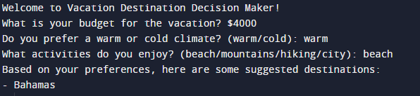
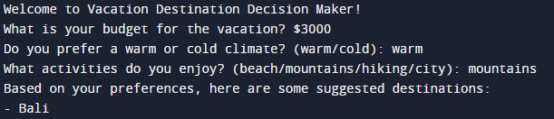

VIVA OR STIMULATING QUESTIONS:
- Why did you choose a list to represent vacation destinations, and how are destination attributes stored within the list?
- Can you discuss alternative data structures that could be used to store and organize destination information?
- How did you use the input() function to collect user preferences? Did you implement any validation for user inputs?
- How might you extend the user input handling to make the interface more user-friendly?
- Explain the process of splitting the user's list of activities into individual preferences. How did you handle variations in user input?
- How might you modify this process to handle a more extensive list of activities?
- How did you implement the random selection of a destination from the list of compatible destinations?
- Describe the loop structure that allows users to continue entering preferences or exit the application. How did you implement this flow?
- Can you discuss any potential improvements to the program's flow and user interaction?
- How would you modify your code to handle a growing list of vacation destinations and user preferences?

RESULT:
Thus, the application Vacation Destination Decision Maker is developed based on user preferences.

EX NO:04 | TEMPERATURE MONITOR: DEVELOP AN APPLICATION FOR A TEMPERATURE MONITORING SYSTEM AND PROVIDE AN ALERT MESSAGE

AIM:
To develop a Develop an application for a temperature monitoring system and provide an alert message.

PROCEDURE:

Step 1: Install Required Libraries:
- Ensure that you have Python installed on your system.
- No additional libraries are required for this simple example.
Step 2: Create the Temperature Monitoring Script
- Define a function read_temperature() to simulate temperature readings between 20 and 30 degrees Celsius
- Set a threshold value for the temperature.
- Create a function monitor_temperature() that checks if the current temperature is above the threshold and returns a boolean and the current temperature
- Use a while True loop to continuously monitor the temperature.
- Inside the loop, call the monitor_temperature() function to check if the temperature is above the threshold.
- If an alert is triggered, print an alert message indicating that the temperature is above the threshold.
- If no alert is triggered, print a normal temperature message.
- Add a time delay using time.sleep(5) to wait for 5 seconds before checking the temperature again
Step 3: Create the Alert Message Script
- Extend your existing script to include more detailed alert messages or actions.
- For example, you could send an email notification, log the alert to a file, or integrate with other notification services.
- Modify the monitor_temperature() function to include additional actions when an alert is triggered.
Step 4: Run the Script
- Save the script with an appropriate filename and a .py extension.
- Open a terminal or command prompt and navigate to the directory containing your script.
- Run the script by executing the command python script_name.py (replace script_name.py with the actual name of your script).

Program
import random
import time
# Function to simulate temperature sensor reading
def read_temperature():
return random.uniform(20, 30) # returns a random float between 20°C and 30°C
# Set the threshold temperature
threshold = 25.0
# Function to monitor the current temperature and compare it with the threshold
def monitor_temperature():
temperature = read_temperature()
if temperature > threshold:
return True, temperature
else:
return False, temperature
# Main monitoring loop
while True:
alert, current_temperature = monitor_temperature()
if alert:
print(f"ALERT: Temperature is above the threshold! Current temperature: {current_temperature:.2f}°C")
else:
print(f"Temperature is normal. Current temperature: {current_temperature:.2f}°C")
time.sleep(5) # wait for 5 seconds before the next reading
SAMPLE OUTPUT:
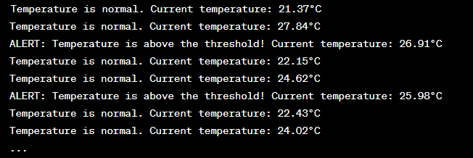

VIVA OR STIMULATING QUESTIONS:
- Why is it important to install required libraries before running the script? Which library did you install for this program?
- Can you discuss alternative libraries that could be used for temperature monitoring, and why you chose the one you did?
- Explain how the read_temperature() function generates random temperature values between 20 and 30 degrees Celsius.
- How might you modify this function to simulate more realistic temperature readings?
- Describe the significance of the threshold variable in the program. Why did you choose a threshold of 25.0 degrees Celsius?
- How would you dynamically adjust the threshold based on specific monitoring requirements?
- How would you modify the loop to allow for a specific duration of monitoring?
- How might you enhance the alert message to provide more information or instructions?
- How realistic is the simulated temperature data generated by the read_temperature() function? What challenges might arise in a real-world temperature monitoring system?
- How might you adjust the sleep duration for different monitoring scenarios?

RESULT:
Thus, the temperature monitoring system and provide an alert message has been executed successfully.

EX NO:05 | DEVELOP AN ACCESS CONTROL SYSTEM THAT SIMULATES THE GRANTING ACCESS TO AUTHORIZED PERSONNEL BASED ON THEIR CREDENTIALS, SUCH AS ID CARDS AND PIN CODES

AIM:
The aim of this experiment is to develop an application using Python to develop an access control system that simulates granting access to authorized personnel based on their credentials, such as ID cards and PIN codes.
PROCEDURE:
Step 1: Create signup() function:
- Takes user input for email, password, and confirmation of the password.
- Checks if the confirmation password matches the password.
- If the passwords match, it encodes and hashes the password using MD5.
- Writes the email and hashed password to a file called "credentials.txt".
- Prints a success message if the registration is successful.
Step 2: Create login() function:
- Takes user input for email and password.
- Hashes the entered password using MD5.
- Reads the stored email and password hash from "credentials.txt".
- Compares the entered email and hashed password with the stored values.
- Prints a success message if the login is successful.
Step 3: Create the main loop:
- Continuously displays a menu with options for signup, login, and exit.
- Read the user's choice.
- Calls the appropriate function (signup or login) based on the user's choice.
- Exits the loop when the user chooses option 3.

PROGRAM:
import hashlib
# Function to sign up a new user
def signup():
email = input("Enter ID/Email: ")
pwd = input("Enter PIN code: ")
conf_pwd = input("Confirm PIN code: ")
if conf_pwd == pwd:
enc = conf_pwd.encode()
hash1 = hashlib.md5(enc).hexdigest()
with open("credentials.txt", "w") as f:
f.write(email + "\n")
f.write(hash1)
print("You have registered successfully!")
else:
print("PIN code does not match. Please try again.\n")
# Function to login existing user
def login():
email = input("Enter ID/Email: ")
pwd = input("Enter PIN code: ")
auth = pwd.encode()
auth_hash = hashlib.md5(auth).hexdigest()

try:
with open("credentials.txt", "r") as f:
stored_email, stored_pwd = f.read().split("\n")
if email == stored_email and auth_hash == stored_pwd:
print("Access Granted. Logged in Successfully!")
else:
print("Access Denied. Invalid credentials.\n")
except FileNotFoundError:
print("No registered users found. Please sign up first.\n")
# Main menu loop
while True:
print("\n********** ACCESS CONTROL SYSTEM **********")
print("1. Signup")
print("2. Login")
print("3. Exit")
try:
ch = int(input("Enter your choice: "))
if ch == 1:
signup()
elif ch == 2:
login()
elif ch == 3:
print("Exiting the system.")
break
else:
print("Invalid choice. Please select 1, 2 or 3.")
except ValueError:
print("Please enter a valid number.")
SAMPLE OUTPUT:
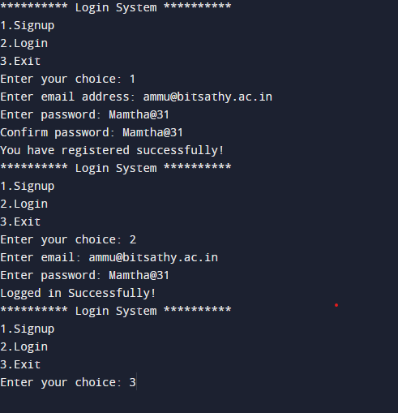

VIVA OR STIMULATING QUESTIONS:
- Why did you choose to hash passwords using MD5? What are the advantages and disadvantages of using MD5 for password hashing?
- How might you enhance the security of password storage in your application?
- How would you modify the file handling logic to store user credentials in a more secure manner?
- Did you implement any input validation in the signup() function, such as checking for valid email formats or password strength?
- How might you enhance the input validation to improve the robustness of your application?
- How might you improve the user interface to make it more user-friendly and intuitive?
- Describe the logic for calling the appropriate function (signup or login) based on the user's menu choice.
- How would you extend the menu to include additional functionalities, such as password recovery or account deletion?
- Can you explain how user credentials persist between different sessions of the program?
- How would you modify the program to support a more robust data storage solution, such as a database?

RESULT:
Thus, the application to develop an access control system that simulates granting access to authorized personnel based on their email and password.

EX NO:06 | MATH QUIZ GENERATOR: DESIGN A MATH QUIZ GENERATOR THAT GENERATES QUESTIONS OF VARIOUS DIFFICULTY LEVELS AND ARITHMETIC OPERATIONS

AIM:
The aim of this experiment is to develop an application using Python to generate questions of various difficulty levels and arithmetic operations.
PROCEDURE:
Step 1: Define the Quiz Parameters:
- Decide on the total number of questions in the quiz (e.g., num_questions).
- Determine the desired difficulty levels (e.g., "easy," "medium," and "hard").
- Choose the arithmetic operations to include (e.g., addition, subtraction, and multiplication).
Step 2: Generate Questions:
For each question in the quiz (from 1 to num_questions), repeat the following steps:
- Randomly select a difficulty level (e.g., using random.choice()).
- Randomly select an arithmetic operation (e.g., using random.choice()).
- Based on the selected difficulty and operation, generate a math question and its answer.
Step 3: Question Generation:
- Create functions for generating questions based on the selected difficulty level and operation.
- These functions should generate random numbers based on the chosen difficulty level and apply the selected arithmetic operation.
- The questions should be formatted as strings (e.g., "What is 3 + 5?") along with the correct answer.
Step 4: Store Questions
Store each generated question and its correct answer in a data structure, such as a list or a dictionary.
Step 5: Quiz Presentation:
Present the quiz to the user, one question at a time.
For each question, display the question to the user and prompt them to enter their answer.
Step 6: User Input and Scoring:
- Accept the user's input as their answer.
- Compare the user's answer to the correct answer.
- Keep track of the user's score (i.e., the number of correct answers).
Step 7: Provide Feedback:
- After each question, inform the user whether their answer was correct or not.
- Display the correct answer if the user's response is incorrect.
Step 8: End of Quiz:
After all questions have been presented, provide the user with their final score.

PROGRAM:
import random

# Function to generate an addition question
def generate_addition_question(difficulty):
if difficulty == "easy":
num1 = random.randint(1, 10)
num2 = random.randint(1, 10)
elif difficulty == "medium":
num1 = random.randint(10, 50)
num2 = random.randint(10, 50)
else: # "hard"
num1 = random.randint(50, 100)
num2 = random.randint(50, 100)

question = f"What is {num1} + {num2}?"
answer = num1 + num2
return question, answer

# Function to generate a subtraction question
def generate_subtraction_question(difficulty):
if difficulty == "easy":
num1 = random.randint(1, 10)
num2 = random.randint(1, 10)
elif difficulty == "medium":
num1 = random.randint(10, 50)
num2 = random.randint(1, 10)
else: # "hard"
num1 = random.randint(50, 100)
num2 = random.randint(10, 50)

question = f"What is {num1} - {num2}?"
answer = num1 - num2
return question, answer

# Function to generate a multiplication question
def generate_multiplication_question(difficulty):
if difficulty == "easy":
num1 = random.randint(2, 5)
num2 = random.randint(2, 5)
elif difficulty == "medium":
num1 = random.randint(6, 10)
num2 = random.randint(2, 5)
else: # "hard"
num1 = random.randint(6, 10)
num2 = random.randint(6, 10)

question = f"What is {num1} * {num2}?"
answer = num1 * num2
return question, answer

# Main function to generate the quiz
def generate_quiz(num_questions, difficulty, operations):
quiz = []

for _ in range(num_questions):
operation = random.choice(operations)
if operation == "addition":
question, answer = generate_addition_question(difficulty)
elif operation == "subtraction":
question, answer = generate_subtraction_question(difficulty)
elif operation == "multiplication":
question, answer = generate_multiplication_question(difficulty)
else:
raise ValueError("Invalid operation selected.")
quiz.append((question, answer))

return quiz

# Function to display and evaluate the quiz
def take_quiz(quiz):
score = 0
for i, (question, answer) in enumerate(quiz, start=1):
print(f"Question {i}: {question}")
user_answer = input("Your answer: ")
try:
if int(user_answer) == answer:
print("Correct!\n")
score += 1
else:
print(f"Wrong. The correct answer is {answer}.\n")
except ValueError:
print(f"Invalid input. The correct answer is {answer}.\n")
print(f"Your final score: {score}/{len(quiz)}")

if __name__ == "__main__":
num_questions = 5
difficulty = "medium" # Choose from "easy", "medium", or "hard"
operations = ["addition", "subtraction", "multiplication"]

quiz = generate_quiz(num_questions, difficulty, operations)
take_quiz(quiz)

SAMPLE OUTPUT:

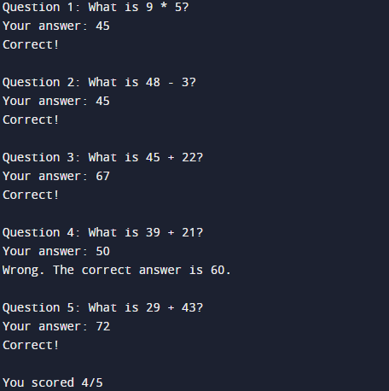
VIVA OR STIMULATING QUESTIONS:
- How did you determine the total number of questions for the quiz (num_questions)?
- Can you discuss the considerations that went into choosing difficulty levels and arithmetic operations for the quiz?
- Explain how you implemented random selection of difficulty levels and arithmetic operations using the random.choice() function.
- How might you extend the program to include additional difficulty levels or arithmetic operations?
- Why did you choose a particular data structure (e.g., list or dictionary) to store the generated questions and answers?
- Can you discuss the advantages and disadvantages of using different data structures for this purpose?
- Describe the format of the questions presented to the user. How did you structure the questions as strings?
- How did you implement scoring for the quiz? Did you provide feedback to the user on their performance?
- How might you enhance the scoring system to include additional metrics, such as time taken to answer each question?
- How would you modify the program to allow users to skip questions or revisit previous ones?

RESULT:
Thus, the application Math Quiz Generator is developed at various difficulty levels and arithmetic operations.

EX NO:07 | BUILD A MAZE SOLVER APPLICATION THAT FINDS A PATH FROM THE ENTRANCE TO THE EXIT OF A MAZE

AIM:
To build a maze solver application that finds a path from the entrance to the exit of a maze
PROCEDURE:
Step 1: Define the Maze:
Represent the maze as a 2D grid, where each cell can be open, a wall, the entrance, or the exit.
Step 2: Initialize Data Structures:
- Create an open set (usually a priority queue) to store cells to be explored.
- Create a closed set (a set or list) to store cells that have already been explored.
- Add the entrance cell to the open set with a cost of 0 (the initial node).
Step 3: Main Loop:
While the open set is not empty:
- Pop the cell with the lowest cost from the open set. This cell becomes the current cell.
- If the current cell is the exit, a path has been found. You can reconstruct the path and return it.
- Otherwise, mark the current cell as explored by moving it to the closed set.
- For each neighboring cell that is not a wall and is not in the closed set.
Step 4: Calculate the tentative cost to reach that cell from the current cell.
- If this tentative cost is lower than the cost associated with the neighbor (or the neighbor is not in the open set), update the neighbor's cost and set the current cell as the parent of the neighbor.
- Add the neighbor to the open set with the updated cost.
- If the open set becomes empty, and the exit has not been reached, there is no path from the entrance to the exit.
Step 5: Path Reconstruction:
Once the exit cell is reached, you can backtrack from the exit cell to the entrance using the parent pointers set during the search. This will give you the path from the entrance to the exit.
PROGRAM:
def is_valid(x, y, maze, visited):
# Check bounds and if it's an open path and not yet visited
return 0 <= x < len(maze) and 0 <= y < len(maze[0]) and maze[x][y] == 0 and not visited[x][y]
def solve_maze(maze, start, end):
rows, cols = len(maze), len(maze[0])
visited = [[False for _ in range(cols)] for _ in range(rows)]
path = []
def dfs(x, y):
if (x, y) == end:
path.append((x, y))
return True
if not is_valid(x, y, maze, visited):
return False
visited[x][y] = True
path.append((x, y))
# Move in right, down, left, up directions
for dx, dy in [(0, 1), (1, 0), (0, -1), (-1, 0)]:
if dfs(x + dx, y + dy):
return True
path.pop() # backtrack
return False

if dfs(start[0], start[1]):
return path
else:
return None
def print_maze(maze):
for row in maze:
print(" ".join(str(cell) for cell in row))
if __name__ == "__main__":
maze = [
[0, 1, 0, 0, 0],
[0, 1, 0, 1, 0],
[0, 0, 0, 0, 0],
[0, 1, 1, 1, 1],
[0, 0, 0, 0, 0]
]
start = (0, 0)
end = (4, 4)

result = solve_maze(maze, start, end)

if result:
print("Path found:")
for x, y in result:
maze[x][y] = 3 # Mark the path in maze with 3
print_maze(maze)
else:
print("No path found.")
SAMPLE OUTPUT:
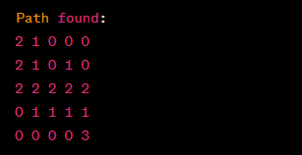

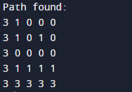
VIVA OR STIMULATING QUESTIONS:
- How did you represent the maze in your program? Can you discuss the advantages and limitations of using a 2D grid for this purpose?
- How might you modify the data representation to handle more complex mazes, such as those with varying cell types?
- Can you discuss alternative data structures that could be used for efficient exploration of the maze?
- How would you modify the initialization step to support multiple entrance and exit points in the maze?
- Explain the main loop of your algorithm, focusing on how cells are selected for exploration.
- Can you discuss any optimizations you implemented to improve the efficiency of the maze-solving process?
- How did you determine the neighbors of a given cell, and how did you calculate the tentative cost to reach each neighbor?
- Can you discuss the factors influencing the cost calculation, especially in the context of finding the shortest path?
- How would you modify your code to handle larger mazes or mazes with more complex structures?
- Did you implement any user interface or visualization components in your application to display the maze and the solving process?

RESULT:
Thus, the application maze solver is developed has been executed successfully.

